Coding in Latex (Specifically for the Cogent Roleplay Rulebook)
Installing Latex and setting up VSCode
https://blog.jakelee.co.uk/getting-latex-working-in-vscode-on-windows/#:~:text=Search%20for%20%E2%80%9CLaTeX%20Workshop%E2%80%9D%20and,close%20and%20reopen%20it%20yourself.
Follow the above guide to install Latex and set it up with VSCode. Important, install the full scheme or the medium scheme instead of Latex only, otherwise you’ll have issues with missing packages. It is possible to install these packages using TLShell TeX Live Manager but it’s a faff and you don’t need to!

Building the PDFs
The PDF will build automatically upon saving, or alternatively you can click the green arrow next to the file ribbon: 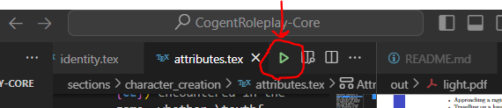
The PDF builds to the out folder as light.pdf. You can view this file within VSCode.
If the PDF does not build successfully (either you get an error or the build message stays showing at the bottom) there are steps to take to track the issue. By showing the terminal (view menu, tick terminal) and then selecting LaTeX compliler under the right hand drop down, you can see the pdf compile output. Generally if there’s an issue it will be seen at the very bottom of the output. Often it’s a syntax error or a missing package on your install.
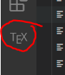
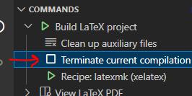
To stop the compilation click of the TEX extension button and then click Terminate current compilation. You may have to double click.
Now before recompiling, you should delete the out directory. This is as sometimes a failed compilation leaves half finished files in this folder that then cause any subsequent compiles to fail.

Project Structure
All of the content files are found under sections. Each section (or part as Latex calls them) of the rulebook has a separate folder under this folder. Examples are introduction and character_creation. Within these sections each chapter has its own .tex file. It is within these files that the content of the pages lies. The only other important file is main.tex in the root directory. This file is responsible for collating all the sections and chapters. Within it you can see the links to the chapter .tex files.

Latex Formatting
You’ll often see \label{this_is_my_label_name} in the following examples. These labels allow you to reference within the text using \ref{this_is_my_label_name}. In most cases they are not necessary but adding them is a good idea for later! The wording of these labels can be anything, but for easy organization we use things like sec: and fig: to sort our labels.
Creating a new book section (part)
Use /part{This is the part title} within main.tex.
Creating a new chapter
Within main.tex add a new block to link the chapter. This will look like:

Now just create a new .tex file at the right path, and it will appear in the final document.
Text within .tex files
You can just type plain text into your chapter file and it will be added to the document. For bold text you must use \textbf{This is my bold text} rather than the double ** as in markdown. For italic text use \textit{___}. Do not use “&” alone in text. This will cause errors. Always type “\&”. The slash will not show in the final file. In order to get a new line you need to leave an empty line between the paragraphs. A single enter will not do it.
Sections within Chapters
Adding a section is also super easy. Just use
\section{Section Titles are So Cool} \label{sec:section_titles_are_so_cool}
Subsections within Sections
Add a subsection as follows:
\subsection{Subsection Time!} \label{sec:subsection_time}
Bulleted List

Numbered List

Indenting Text
To indent text we’ll use the following code:

Tables in LaTeX
Tables in latex are a real pain ☹. Here’s a template though!

The text in the cirly brackets after \begin{tabular} set the tables vertical lines and horizontal text alignment. A l gives left-alignment, a r right and a c centered. If two columns are seperated by a | then a vertical line is drawn. If two columns are seperated by a space then no line seperated the columns. To create horizontal lines on our table we must use \hline within the table. For each row we add a line that has each cells contents seperated by & and then finished with a double slash \\. More is possible than this but it is a good starting point.

Images in Latex
Below is a simple way to import a picture to the document.

